Spike: Spike 38
Title: Sound
Author: Rachel McQueenie 696737x

Goals / deliverables:
- An application that can:
  - Play a unique sound when the 1, 2, or 3 keys are pressed, even if the sound is already playing
  - Play / pause music with the 0 key

Technologies, Tools, and Resources used:
- Windows 7
- Visual Studio Professional 2012
- SDL_Mixer Library
  - http://www.libsdl.org/projects/SDL_mixer/
- Lazyfoo SDL 2.0 Lesson 21: Sound Effects and Music
  - http://lazyfoo.net/tutorials/SDL/21_sound_effects_and_music/21_sound_effects_and_music.zip
- Lazyfoo: Setting up SDL Extension Libraries in Visual Studio.NET 2005/2008 Express
  - http://lazyfoo.net/SDL_tutorials/lesson03/windows/msvsnet2010e/index.php
- PacDV Free Sound Effects: Dance Zone
  - http://www.pacdv.com/sounds/free-music-13.html
- Public Domain Sounds: Walking through the grass
  - http://publicsounds.org/nature/walking-through-the-grass/
- Public Domain Sounds: Burning Matches, Successful Ignition
  - http://publicsounds.org/kitchen/burning-matches-successful-ignition/
- Public Domain Sounds: Hammer knocking nail into a plank of pine wood
  - http://publicsounds.org/metals/hammer-knocking-nail-into-a-plank-of-pine-wood/
- Media.io Online Audio Converter
  - http://media.io/
- SDL tutorial 12 - sound with SDL_mixer
  - http://www.youtube.com/watch?v=94pPyuS1E_M

Tasks undertaken:
- Complete Spike 35 to initialise SDL.
- Complete Spike 36 to set up keyboard events.
- Download and install SDL_Mixer for SDL2 (SDL2_Mixer). Be sure to get the one for Visual C++ as we are using Visual Studio for development
- Download the audio files (refer to Resources list) and put them in a folder called 'audio'
- Go to Media.io and convert the audio files to WAV, as SDL_Mixer supports WAV files much better than their current format, which is MP3. MP3 requires extra tweaking which is beyond the scope of this Spike.
- Link SDL2_Mixer to the project
  - Extra the ZIP file downloaded from Step 3
  - Open up the newly extracted folder. Locate the include folder. Copy the contents of this folder to the SDL include folder that your project has already had linked to it from Step 1.
  - Go back to the extracted folder and locate the lib folder. From here, select x86 and copy the contents to the SDL lib/x86 set up from Step 1
  - Open your Project in Visual Studio and go to Project → Properties. From here, go to Linker → Input. Add SDL2_mixer.lib to your Additional Dependencies.
- Set up your includes:
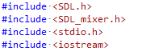
- Set up your audio variables. Mix_Chunk* for sound effects and Mix_Music* for music.
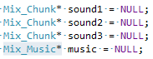
- Open the Audio:
- Make your variables point to the sound files from Step 4 and 5. Check for NULL to make sure all the files could be loaded.
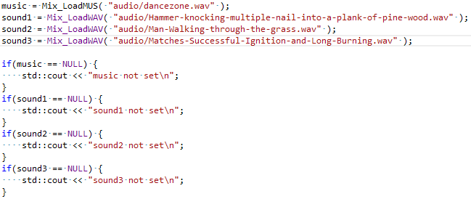
- Set the volume:
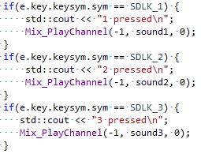
- Using the existing keyboard event code, add the code for playing the sound effects when 1, 2 and 3 are pressed:

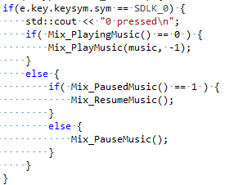
- Using the existing keyboard event code, add the code for playing / pausing the music when 0 is pressed:

- Free the memory:
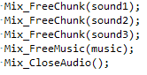
What we found out:
- SDL_Mixer can be used to load, play and control game sound and music, which is demonstrated in the Task list.
- The first parameter in Mix_OpenAudio() specifies the frequency that the audio will play at. I went with 44100 as that is the recommended frequency for WAV formatted files.
- The third parameter in Mix_OpenAudio() specifies how many channels the mixer will use in the program. However, while testing I found that using more than 4 channels completely stopped the program from working (as in, the audio variables could no longer be set to the sound files and the NULL checks from Step 10 would always return true). I did not, however, find an explanation for this, but thankfully the four channels were sufficient enough for this Spike.
- The first parameter in Mix_PlayChannel() specifies which channel it will use. If this is set to -1 then SDL chooses one for you.
- The last parameter in Mix_PlayChannel() specifies how many times the sound file will loop. If it is set to 0, then it will play through once and then not loop. If this is set to -1 then it will loop forever.
- The second parameter in Mix_PlayMusic() is similar to above. If it is set to -1 it will loop forever, but any other number will specify its number of loops.

Recommendations:
- For the purposes of this spike, WAV files are fine, but for a proper product they are not recommended because they are an uncompressed file format and generally create files far too big to be practical in a game application.
- MP3 files generally aren't favoured either as they require additional licensing.
- A compressed file which doesn't incur addition licensing costs, such as OGG, is often recommended.

